Baseband Wireless Channel Emulator

# Introduction

There are three types model in mobile radio propagation: Large Scale Path Loss, and Shading Losing, and Fading with Multipath (Referring Wireless Communications: Principles and Practice, T. S. Rappaport). We will build a wireless channel emulator on its tapping baseband model, and only Fading and Multipath is considered.

# Structure

## Block Diagram

In the block diagram, s(n) denotes the transmitted signal and r(n) denotes the received signal.

There are M taps in the channel emulator. In the m-th tap, the transmitted signal is delayed by Δnk first, then multiplied by power assignment weight pk, and at last faded by fading coefficient fk(n). Finally all results from the taps are summed up together and the Additive Gaussian Noise is added.

All signals and coefficients except the power weight pk are complex numbers.



Figure (1) Block Diagram

The delay quantity can be simply selected by the equation:

(1)

Thus the emulator could be used when the bandwidth of the transmitted signal is less than . (Referring Wireless Communications: Principles and Practice, T. S. Rappaport)

The power weight pk are predetermined constants following the equation:

(2)

The fading coefficient fm(n) follows the Rayleigh distribution. can be computed by the following equation:

## Detailed Design

By selecting in Equation (1) and in Equation (2), we get the equation of the time variant impulse response:

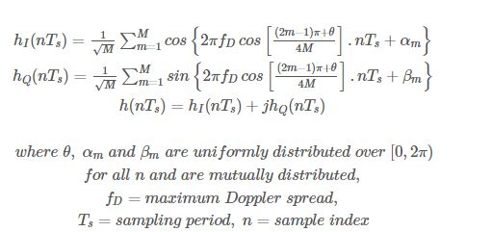 (3)

(Referring <http://www.gaussianwaves.com/2011/05/simulation-of-rayleigh-fading-clarkes-model-sum-of-sinusoids-method-2/> and <http://library.utem.edu.my/index2.php?option=com_docman&task=doc_view&gid=5459&Itemid=342> )

And the emulator can be simplified to:

(4)

where is the time variant impulse response whose length is N.

The data flow diagram is shown in the following figure:



Figure (2) Signal Flow Diagram

Uniform random numbers are generated by the following equation:

(5)

Where，u is random numbers; n is a primer in format of 2k + 1; g is the minimum Primitive root modulo n; the initial value of u(0) and n should be relatively prime. For example, n = 216 +1 = 65537, g = 75 and u(0) = 4.

, and is computed by selecting the initial values respectively then recurrence by Equation (5). They also must be scaled to their range respectively.

is generated by the following Equation (6) or Equation (7):

(6)

(7)

where u(n) and v(n) are independent random numbers distributed [uniformly](https://en.wikipedia.org/wiki/Uniform_distribution_(continuous)) on (0, 1), and is the strength of the noise.